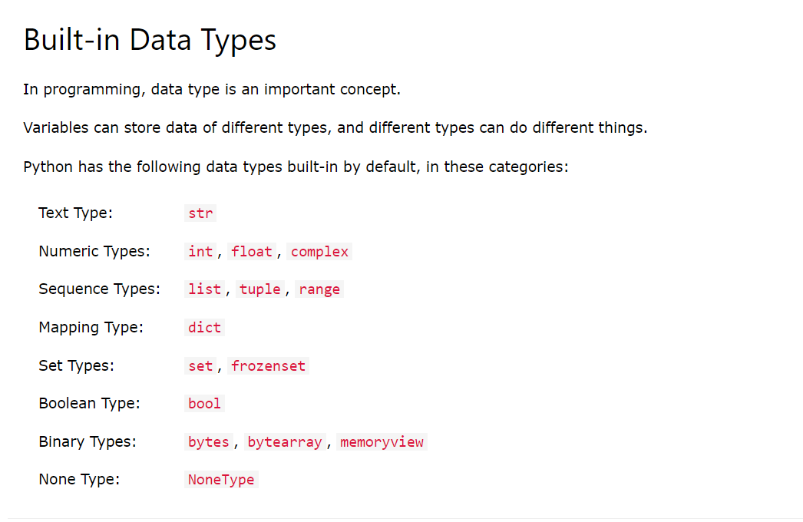

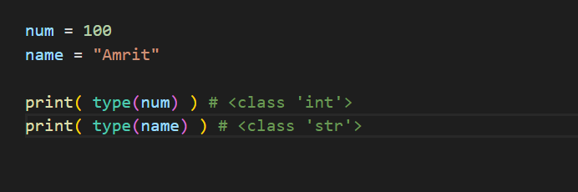

We do not need to specify while declaring variables but internally python automatically manages data types as per the values assigned to the variables

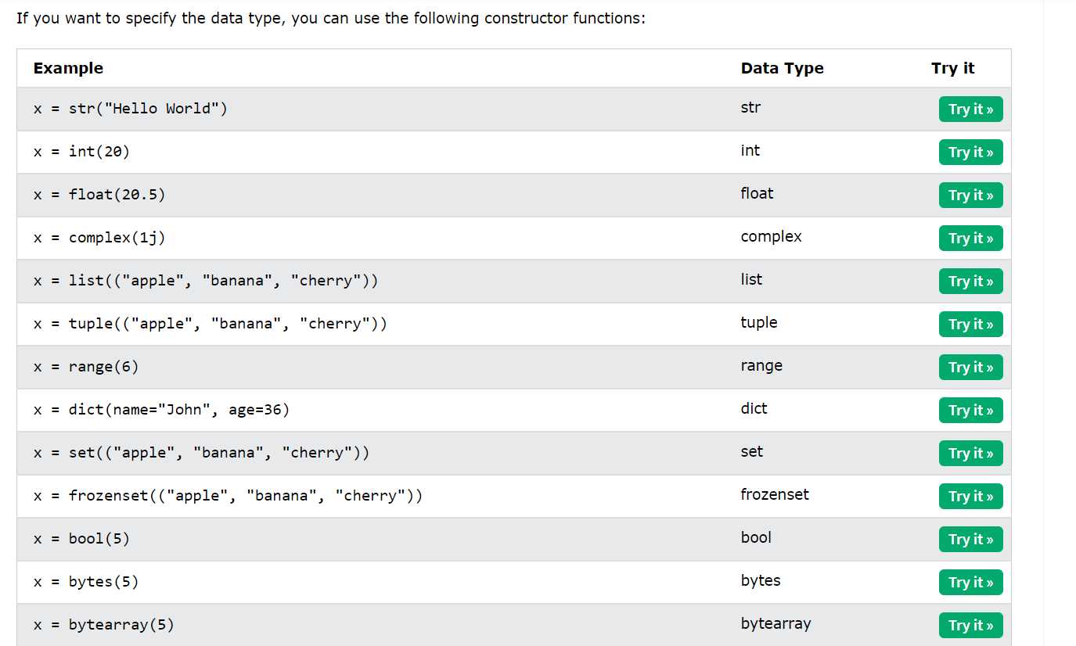

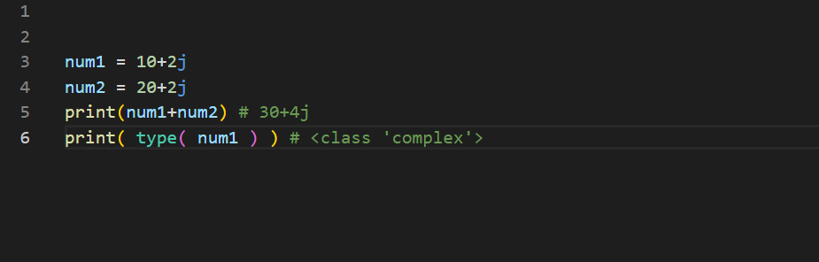

There is a complex data type that handles the complex numbers

**Conversion from float to int**

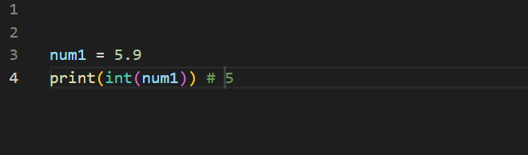

It just removes everything after decimal

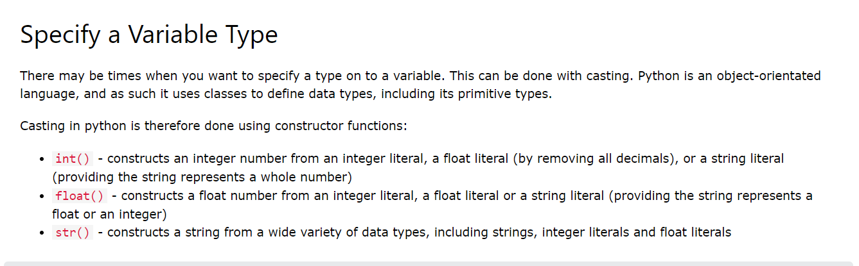

Remember these are constructor functions

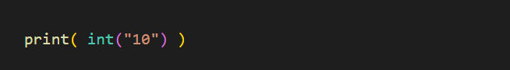

When we do this there is a class defined in python as int

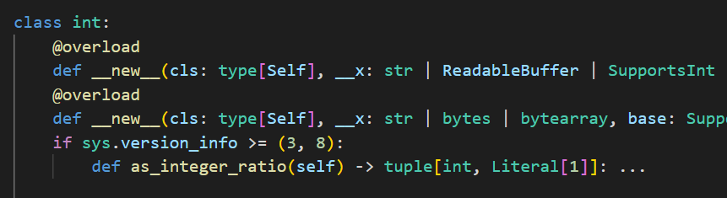

Hence the constructor of that class is called and then an object or instance of that class is created

